# **Business Requirements**

# Product Vision

**Product Title:**

CitiSense: A SMART web application for Automated Billingual Feedback Processing and Data Visualization.

**Project Description:**

CitiSense serves as a web application that utilizes an NLP model for sentiment analysis to process data in both Tagalog and English. This system categorizes feedback into three groups—positive, neutral, and negative— and presents the data through interactive visualizations for easy interpretation and gain insights on user feedback.

**What makes it stand out?**

CitiSense distinguishes itself from standard English-only systems by offering specialized support tailored to DOST needs, utilizing an NLP model trained or fine-tuned, for sentiment classification in both Tagalog and English. The system integrates seamlessly with DOST’s services feedback form, offering an inclusive approach to analyzing locally collected data coming from DOST themselves. With a user-friendly design, it automatically categorizes feedback data into positive, negative, and neutral sentiment— presenting the analyzed data into interactive visualizations for easy interpretation and generating actionable insights.

**Deliverables/Outcomes:**

The primary deliverable will be a web application that can analyze feedback in Tagalog and English utilizing an NLP model. It features dashboards for real-time sentiment visuals. Feedback will be auto-categorized as positive, negative, or neutral.

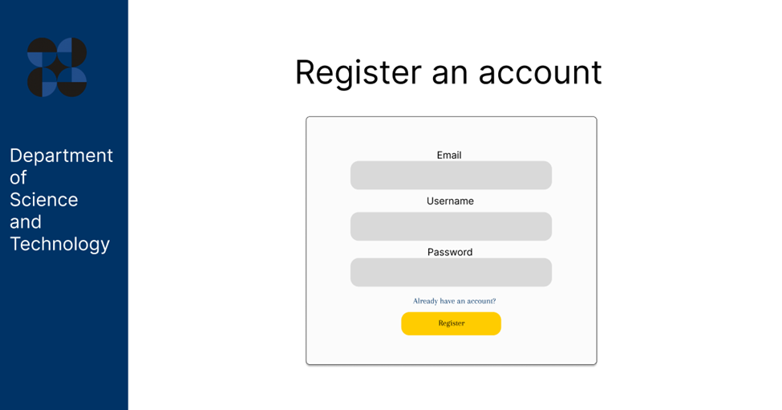

Figure 1. Register UI of CitiSense web application

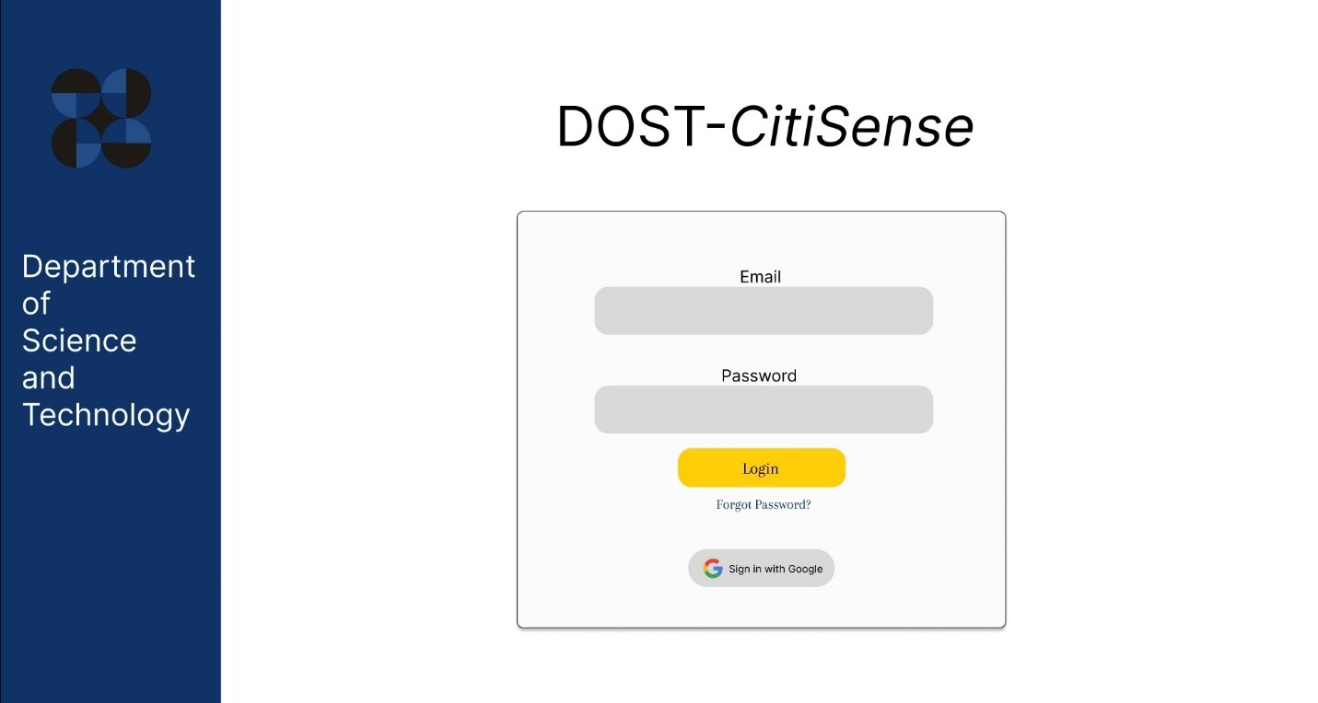

Figure 2. Login UI of CitiSense web application

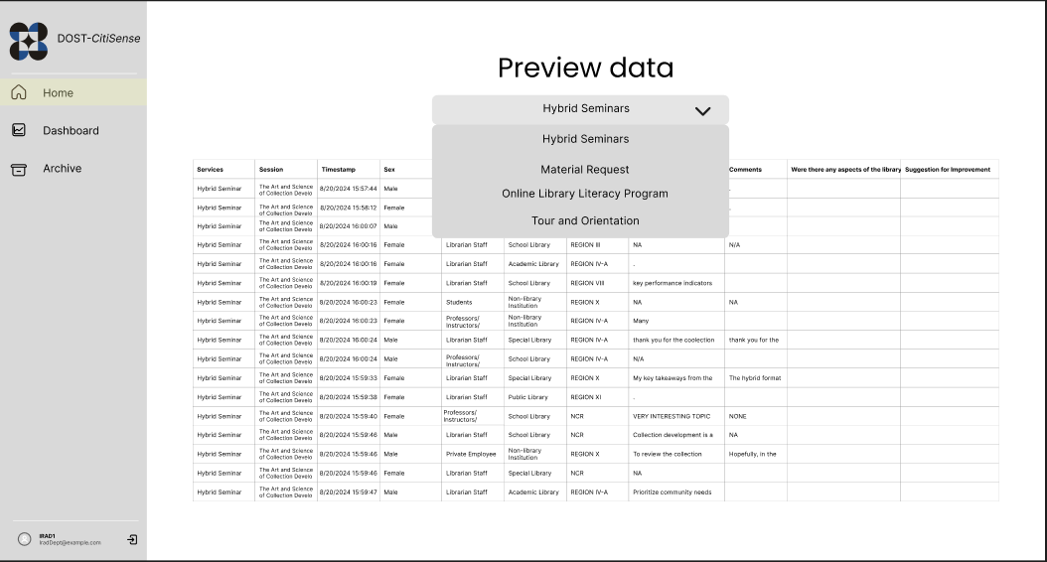

Figure 3. Preview Data tab UI

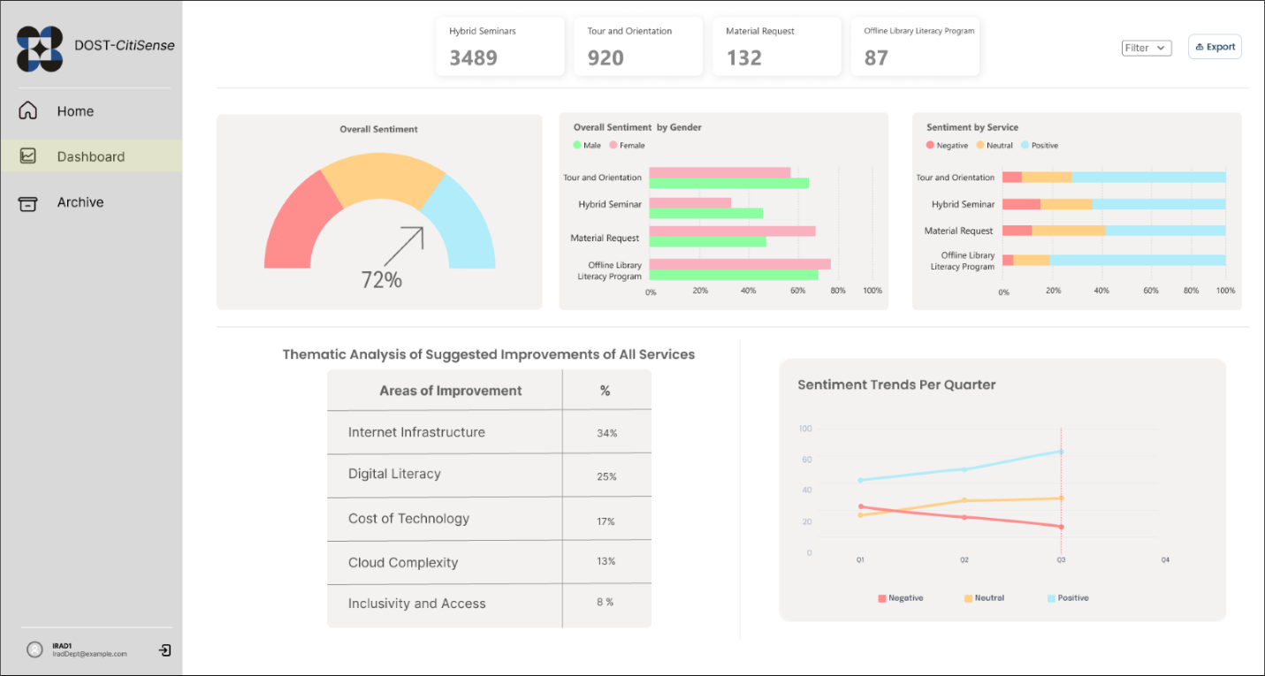

Figure 4. Dashboard of the CitiSense web application

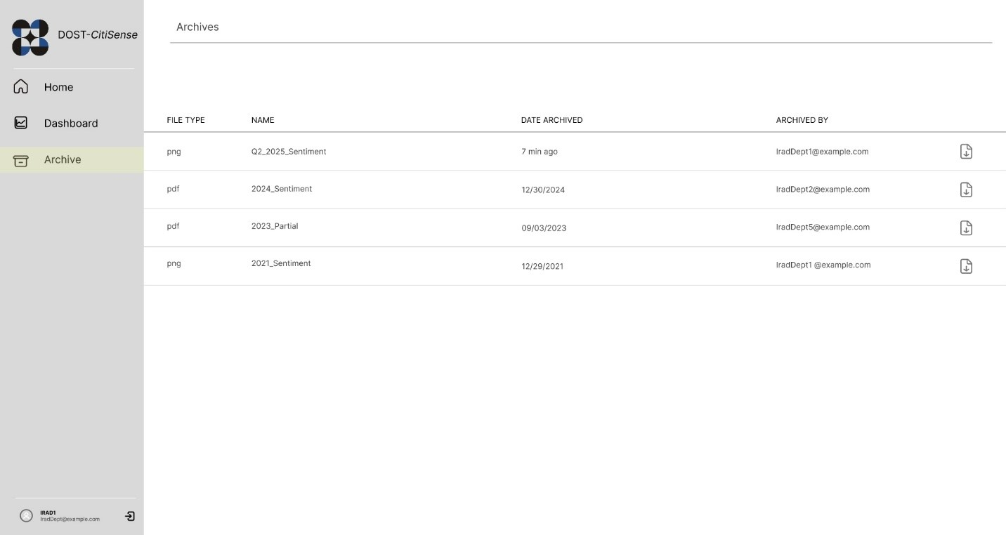

Figure 5. View archived visualization results of the CitiSense web application.

**Environmental Scan**

* **Power BI:**
* A Microsoft-developed data analytics platform that enables data visualization. Through visualization techniques, the program converts basic information into dashboards combined with operational reports. The data originates from cloud services, along with databases and Excel. Through visual report generation, Power BI aids business operations and enhances performance with dynamic visualization capabilities available to users regardless of their IT understanding.

# Product Scope

**Product Objectives**

* Develop an automated sentiment detection system that will help users efficiently analyze a large volume of user feedback.
* Support multilingual sentiment detection (English and Tagalog) and provide a visualization dashboard feature with filters for easier data interpretation.
* Reduce the manual analysis time by 70% through automation and visualization representation of sentiment results.
* Support the government institution through the development and deployment of an AI-powered system that streamlines the analysis of user feedback.

**Functionality & Technology**

**Inclusion**

* Authentication
* Fine-tuned NLP multilingual sentiment analysis model (Tagalog and English)
* Visualization dashboard with filters
* Downloadable reports in .png or .pdf format

**Exclusion**

* Data import feature
* Customizable Dashboards (future implementation)
* Further fine-tuning of the sentiment analysis model (considered for future implementation)

**Audience**

**Primary Market Segment:**

* Government and Educational Institutions – Specifically, data analysts, librarians, and decision-makers within DOST STII and the 11,000 schools nationwide using offline digital libraries. The analyzed sentiments help these institutions achieve better service outcomes and strengthen user interactions.

**Secondary Market Segment:**

* Students together with Educators form a segment that provides evaluation about digital libraries and hybrid training and webinar platforms to improve learning programs and resource availability.
* The Information Resources and Analysis Division (IRAD) department of DOST STII enables Researchers and Professionals to enhance their research and knowledge-sharing operations.
* Any individual accessing DOST STII’s digital or physical library services counts as a library patron or general information seeker who aids in evaluating service quality.

**Target Customers & Users**

**Target Customers:**

* The educational institutions serve as target customers because they need sentiment analysis tools to evaluate their services and boost performance.
* Academic and research institutions consisting of universities and research centers alongside schools use data-driven insights as their benefits.

**Primary Users:**

* Data Analysts – Professionals handling sentiment analysis and feedback categorization.
* Personnel – Professionals that handle the overall system.

**Key Stakeholders**

* **Information Resources and Analysis Division (IRAD) - (Primary User):**
* They will collect user feedback and offer interpretations based on sentiment trends.
* **Project Manager - (Project Lead and Facilitator):**
* They oversee guiding the teams involved in developing the sentiment analysis system and ensuring that the project is finalized on time and aligned with the given objectives.
* **IT Department of DOST-STII - (Technical Support):**
* They will manage and provide the technical infrastructure needed for the project.
* **Developers (QuadThink) - (System Developers):**
* In charge of developing a sentiment analysis system with a web-based dashboard for visualization, documentation, and training materials for end-users.
* **Legal and Compliance Team - (Compliance Advisors):**
* They ensure that the project complies with relevant data privacy requirements and laws and handles any legal considerations in terms of data usage.

# Product Market Research

**User stories**

* As a customer service agent, I want a tool that can detect and categorize emotional tones expressed in a text in both English and Tagalog, especially highlighting negative feedback, so that I can address the concerns, relay them to appropriate departments, and improve future customer interactions.
* As a data analyst, I want a system that can automatically generate visualizations of user sentiment trends, so that I can quickly interpret results on user perceptions across all services provided by my department.

**Use Case diagram**

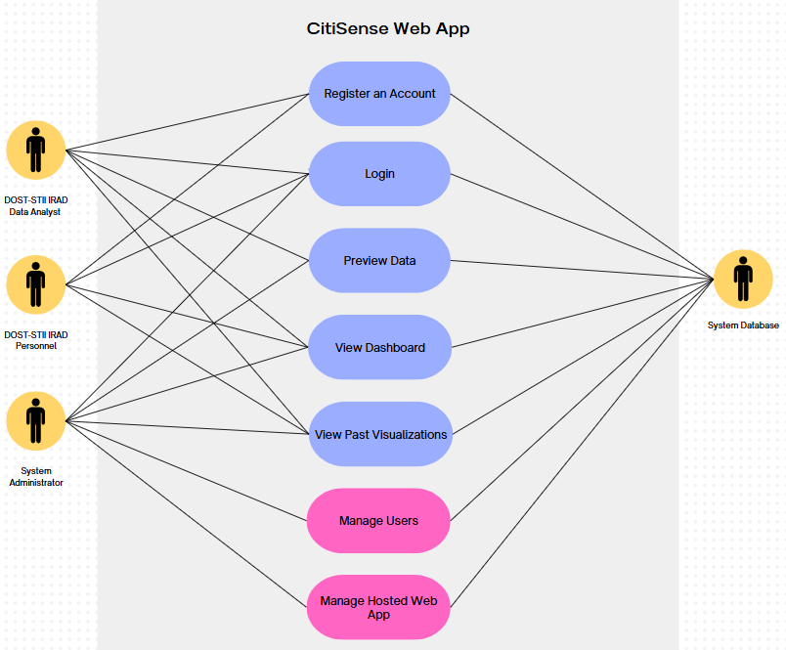

Figure 6. Use Case Diagram of the CitiSense web application

**Project Timeline/Roadmap**

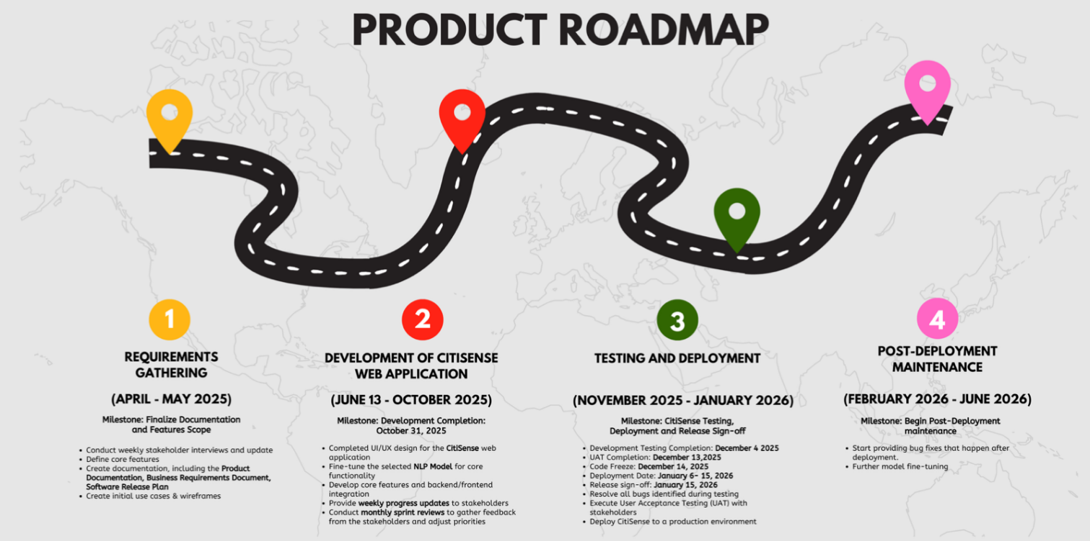

Figure 7. Product Roadmap for the development of the CitiSense web application.